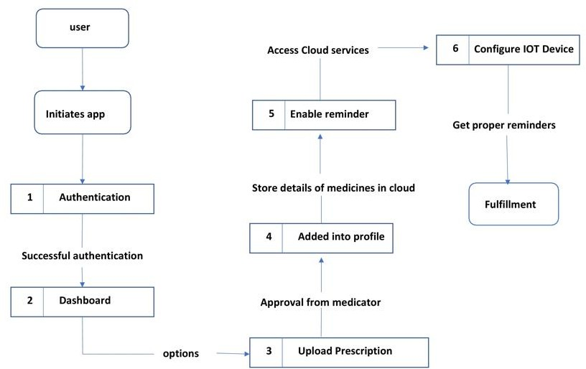

Project Design Phase-II

Data Flow Diagram & User Stories

|  |  |
| --- | --- |
| Date | 19 October 2022 |
| Team ID | PNT2022TMID50154 |
| Project Name | Personal Assistance for Seniors Who Are Self-Reliant |
| Maximum Marks | 4 Marks |

# Data Flow Diagrams:

A Data Flow Diagram (DFD) is a traditional visual representation of the information flows within a system. A neat and clear DFD can depict the right amount of the system requirement graphically. It shows how data enters and leaves the system, what changes the information, and where data is stored.

DFD Level 0 (Industry Standard)

# User Stories

|  |  |  |  |  |  |  |
| --- | --- | --- | --- | --- | --- | --- |
| **User Type** | **Functional**  **Requirement (Epic)** | **User Story Number** | **User Story / Task** | **Acceptance criteria** | **Priority** | **Release** |
| Customer (App user) | Registration | USN-1 | As a user, I can register for the application by entering my email, password, and confirming my password. | I can register myself my to use the application | High | Sprint-1 |
|  |  | USN-2 | As a user, I will receive confirmation email once I have registered for the application | I can receive confirmation email & click confirm | High | Sprint-1 |
|  | Login | USN-3 | As a user, I can log into the application by entering the registered email & password | Through successful login, I can access use the application for further needs | High | Sprint-1 |
|  | Dashboard | USN-4 | As a user, I can use consultation feature in the dashboard. | I can get real time consultations through online | Medium | Sprint - 2 |
|  |  | USN-5 | As a user, I can use voice configuration feature in the dashboard | I can able to change voice speed and tone | Low | Sprint -2 |
|  |  | USN-6 | As a user, I can store the medication details with proper timing. | I can able to see the history of prescriptions | High | Sprint - 1 |
|  |  | USN-7 | As a user, I can use reminder options in the dashboard | I can configure the reminder time to get updates | High | Sprint - 1 |
| Administrator | Admin panel | USN-8 | As an app admin , I can use manage users options in the dashboard | I can manage the user reports | High | Sprint-1 |
|  |  | USN-9 | As an app admin , I can use consultation options in the dashboard | I can directly contact the consultant | Medium | Sprint - 2 |
|  |  | USN-10 | As an app admin, I can configure new alert option in the dashboard. | I can access the device to update to latest version | Low | Sprint - 2 |